# Exercise 9 : ANOVA

TASK 1 :

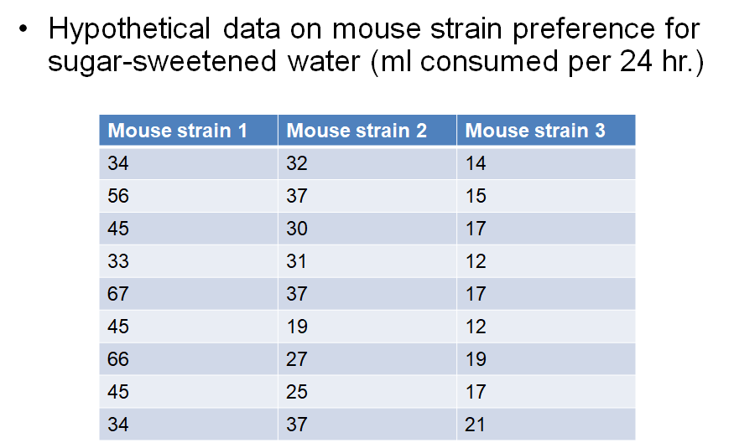

1. State the null, alternative, F value, p value, and conclusion for this task using two methods : a piece of paper and R .
   1. Perform ANOVA by hand.
   2. Enter the above data into MouseData.csv in a way shown below, import into R and perform ANOVA in a manner as such

Volume,MouseStrain

1,A

2,A

23,A

23,B

24,B

33,B

3,C

3,C

1,C

boxplot(MouseData$Volume~MouseData$MouseStrain,col= rainbow(4))

ANOVAresults <- aov(Volume~MouseStrain,data=MouseData)

summary(ANOVAresults)

TASK 2 :

Annual income of households in different cities in Oklahoma. Use at least 4 cities. It should include data for at least 20 individuals. Make a boxplot and a histogram and perform an ANOVA.

The dataset will look something like this:

Income,City

20000,Norman

30000, Norman

(incude more data points)

40000,OKC

50000,OKC

(incude more data points)

80000, Tulsa

40000,Tulsa

Show your code.

State the null, alternative. Use R to calculate F value, p value, and conclusion for this task.

Describe what you learnt.